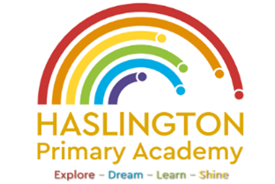

**Haslington Primary Academy: School Council**  
**Minutes of Meeting: Friday 25th October**

In Attendance: Miss de la Haye, Darwin C, Will T, Lily L, Kobi J, Jasmine W, Jack R-W, Sophie M, Oliver P, Elsie P, Harvey L, Hallie M, Ugo O, Edward H, Jim L-M-Y, Ellie P, Harry W

Apologies: N/A

All children are welcomed to the meeting and reminded of meeting protocol, e.g. raising hand to speak, being respectful when listening to other people’s views and ideas and showing empathy for those around us. Children are reminded to take notes in School Council Meeting Book so they can feedback to their class.

|  |  |
| --- | --- |
| Discussion Item | Outcome |
| Welcome | * Miss de la Haye recapped the last school council meeting. |
| Ideas from classmates | * Children shared ideas collected from their class that we could focus on this year. Ideas included: more play equipment outside, looking into warm snacks for purchasing at snack time, more drink options at lunch time, and bringing back football at lunch time |
| Children in Need | * Children discussed the importance of raising awareness for Children in Need and what we could do as a school. * Children suggested a non-uniform day and themed lunch options in the canteen. |
| AOB: | * Children would like to create posters to raise awareness for Children in Need non-uniform day |