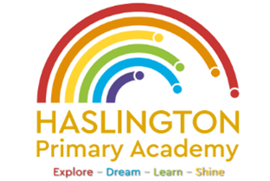

**Haslington Primary Academy: School Council**  
**Minutes of Meeting: Friday 20th December**

In Attendance: Miss de la Haye, Darwin C, Will T, Lily L, Kobi J, Jasmine W, Jack R-W, Sophie M, Oliver P, Elsie P, Harvey L, Hallie M, Ugo O, Edward H, Jim L-M-Y, Ellie P, Harry W

Apologies: N/A

All children are welcomed to the meeting and reminded of meeting protocol, e.g. raising hand to speak, being respectful when listening to other people’s views and ideas and showing empathy for those around us. Children are reminded to take notes in School Council Meeting Book so they can feedback to their class.

|  |  |
| --- | --- |
| Discussion Item | Outcome |
| Welcome | * Children had the opportunity to share any ideas or feedback from their peers. No new ideas were shared. |
| Priorities | * Children came up with a list of things suggested by their peers that could help improve the school. Children voted for their top three priorities as a school councillor, thinking about what their peers would like them to represent the most. * The top three priorities for this year are: bringing back football at lunchtime, introducing warm snacks at playtime, and beginning a litter-picking initiative. |
| AOB: | * In the next session, children would like to begin their campaign to bring back football |