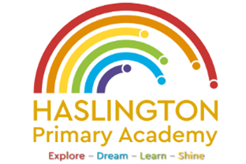

**Haslington Primary Academy: School Council**  
**Minutes of Meeting: Friday 8th November**

In Attendance: Miss de la Haye, Darwin C, Will T, Lily L, Kobi J, Jasmine W, Jack R-W, Sophie M, Oliver P, Elsie P, Harvey L, Hallie M, Ugo O, Edward H, Jim L-M-Y, Ellie P, Harry W

Apologies: N/A

All children are welcomed to the meeting and reminded of meeting protocol, e.g. raising hand to speak, being respectful when listening to other people’s views and ideas and showing empathy for those around us. Children are reminded to take notes in School Council Meeting Book so they can feedback to their class.

|  |  |
| --- | --- |
| Discussion Item | Outcome |
| Welcome | * Children had the opportunity to share any ideas or feedback from their peers. No new ideas were shared. |
| Children in Need | * Children created posters to be shared around the school to raise awareness for a Children in Need themed non-uniform day. |
| AOB: | * In the next session, children would like to create a comprehensive list of school improvement ideas and vote for the Council’s top priorities to focus on this year. |